|  |
| --- |
| BOUN SWE |
| SWE 544 – 2015 Fall |
| Project 2 – Requirements and Design Document |

|  |
| --- |
| Sinan Can SÜRÜCÜ  1/3/2016 |

Contents

Contents 1

Summary 2

Requirements 2

Protocol Summary 4

# Summary

This document is prepared for “Tombala Game” in Python, to clarify the requirements and design of the application.

# Requirements

These are the requirements for both client and server side of the application.

1. User logins with a username
2. User gets the current game sessions list
3. User can create a new game session or can join an existing game sesison.
4. Game starts after 60 seconds of the first user enters the session (or creates the session) or the max number of players(5) is reached.
5. Game Will Start message will be delivered to the clients when 5 seconds left to the game start.
6. Every user gets a 5x3 numbers of ticket with random numbers.
7. Every 5 seconds, a randomly picked number between 1-99 is sent to the users.
8. User selects the number, the number should be sent to the server as it is signed.
9. User selects “Cinko” to sign a row is full with the picked numbers.
10. User gets a valid cinko information, if it is validated in the server, and an announcement has been made for other users.
11. User gets an invalid cinko information, if it can’t be validated in the server.
12. If the user requests more than 3 invalid cinko, user is banned for the current session.
13. Users can see other users cinko statuses.
14. If the user checks all the numbers with the last cinko (in the server control), the game finished announce will be delivered to all users.
15. If a user makes a valid cinko, all other users will be informed.
16. If a user quits from the game, the other users will be informed.
17. Server should check every user in every 3 seconds with TIC-TOC messages if the user is still connected to the current session.

**Client-Server Communication**

The protocol and messaging rules of the client-server communication of the application is shown in the diagram which is below.

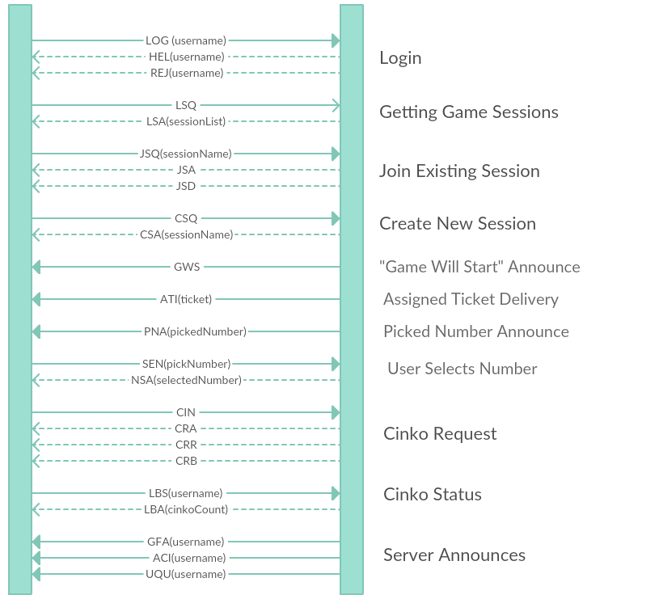

# Protocol Summary

Request-response messages of the protocol are detailed in the table below.

|  |  |  |  |  |
| --- | --- | --- | --- | --- |
| Request | Parameter | Response | Parameter | Definition |
| LOG | username | HEL | username | User login |
| REJ | username | User login rejected |
| QUI |  | BYE | username | User quit |
| LSQ |  | LSA | sessionList | List game sessions |
| JSQ | sessionName | JSA |  | Request to join a game session approved |
| JSD |  | Request to join a game session declined |
| CSQ |  | CSA | sessionName | Create new game session approved |
|  |  | GWS |  | Session ready, game will start |
|  |  | ATI | ticket | User is getting the ticket |
|  |  | PNA | pickedNumber | Randomly picked number announce |
| SEN | pickNumber | NSA | selectedNumber | User selects number |
| CIN |  | CRA |  | Cinko requested, cinko is valid |
| CRR |  | Cinko requested, cinko is invalid |
| CRB |  | Too many invalid Cinko request, user banned for the session |
| LBS | username | LBA | cinkoCount | Learn Cinko status of a user |
|  |  | GFA | username | Game finished, winner username is returned |
|  |  | ACI | username | A user (username) has made a cinko |
|  |  | UQU | username | A user has left the game |
|  |  | ERR |  | Command error |
| TIC |  | TOC |  | Connection ping |